Train It New Mexico can handle all your OSHA Forklift training needs.  This 8-hour course meets the requirements for an OSHA certified forklift operator and includes:  - 4 hours classroom lecture and training  - Written exam  - Hands-on practical demonstration and practice  - Skills evaluation  Those who successfully pass the course receive a certificate from OSHA which is good for three years and are recognized as a certified forklift operator. | Train It New Mexico  423 Capitan Road  Roswell, NM 88201  Arial lift Fire Extingusher  Fall protection  Motorgrader  Dozer  Scraper  Herbicide | Some one somewhere | Train It New Mexico  - Training …. the way to get  - ahead …. today  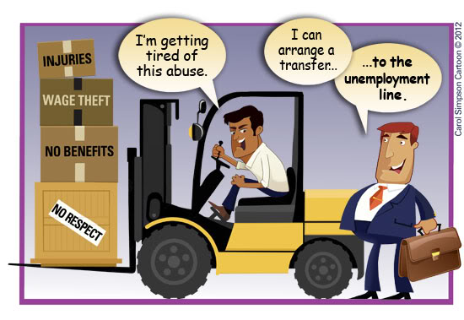
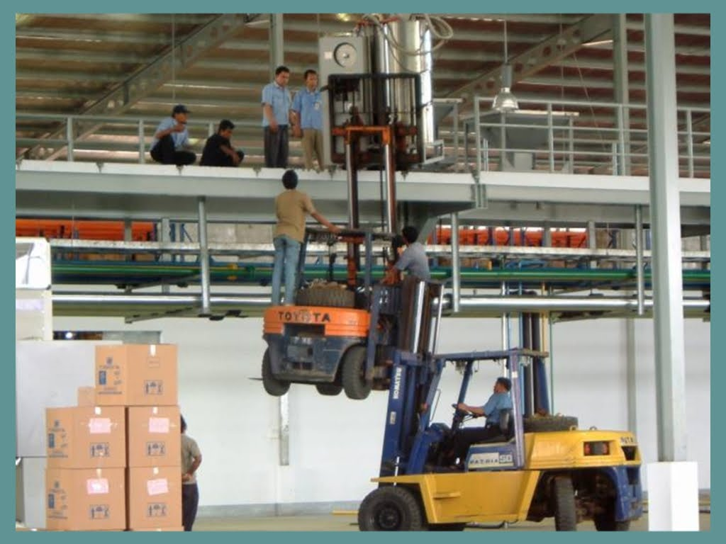  Safety on Forklifts  Somewhere in America someone dies on a forklift every three days. Every six hours someone is hurt bad enough to receive emergency care.  Food for Thought  Every year, in the United States, there are over 100 deaths and 100,000 accidents involving forklifts. We ask, do forklift accident statistics shock you? If not, they should. These statistics shock us and we’ve been in this business for many years.  It’s frightening that in the United States one person is killed in a forklift accident every three days. The greatest number of those deaths occur when a forklift driver attempts to jump from an overturning forklift. | Train It New Mexico Can Help Make the Difference. In today’s society, you cannot be too safe. With the cost of insurance, workman’s comp, and rehabilitation, you cannot be too careful. In-house forklift training that is not OHSA approved can have adverse effects.  For example, a certified forklift operator was unloading a truck with a newly hired individual. After a couple of hours, the new employee kept nagging at the experienced employee to let him learn to operate a forklift. So, the certified operator gave in and the newly hired employee hopped on. After just a few quick directions. he was off! On the third round, he was feeling on top of the world. As he rounded the corner the forklift tipped over. The ROPS caught him on the shoulder and squashed him to the ground, ending his life.  Any accident that involves a forklift requires an inspection from OSHA. When the question was asked if the employee had OSHA approve training, the answer was no! The OSHA fine to the company for this one accident was $100,000, plus the benefits paid to the family. |  | Key Course Outcomes:  - Quality Operators  - Safe Operators  - Confident Operators  Contact Us For More Information and Pricing  Train It New Mexico  423 Capitan Road  Roswell, NM 88201  Arial lift Fire Extingusher  Fall protection  Motorgrader  Dozer  Scraper  Herbicide  575.840.9555  trainitnm@gmail.com  Train It New Mexico has a curriculum for many other classes for training, licensure, or certification. Customized Training is available also.  Arial lift Fire extingusher  Fall protection Scaffolding  Motorgrader Truck & loader  Dozer Backhoe  Scraper Competant person  Herbicide Welding  Competant Operator Testing  Commercial Drivers License

